VIPs
INTERMEDIATE/MIDDLE SCHOOL VIPs
Kodaly Hand Signs
Used during warm-ups. Students sing and do hand signs simultaneously.

Reference VIP
These are common symbols that appear in a piece of music at an intermediate school level. This chart helps to remind students what the symbols mean.

Circle of Fifths VIP
This VIP would be used at a middle school. It is the circle of fifths and is one of the first things students will learn when beginning music theory knowledge.

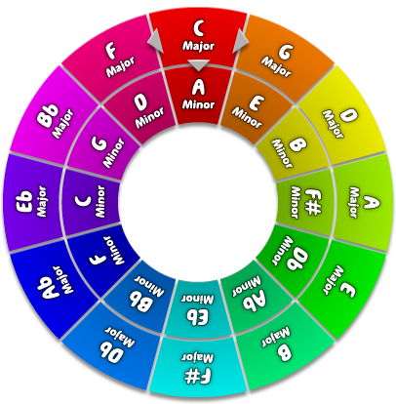

HIGH SCHOOL VIPs
Hierarchy of Notes and Rests
This VIP would be a good one to place in a High School Classroom. this is because the majority of students already know this information by the time they get to high school. Because of this fact, this type of information will not be covered as in depth. So if a struggling student has a chart to reference, they will not stay far behind, they will have an opportunity to catch up to their classmates.
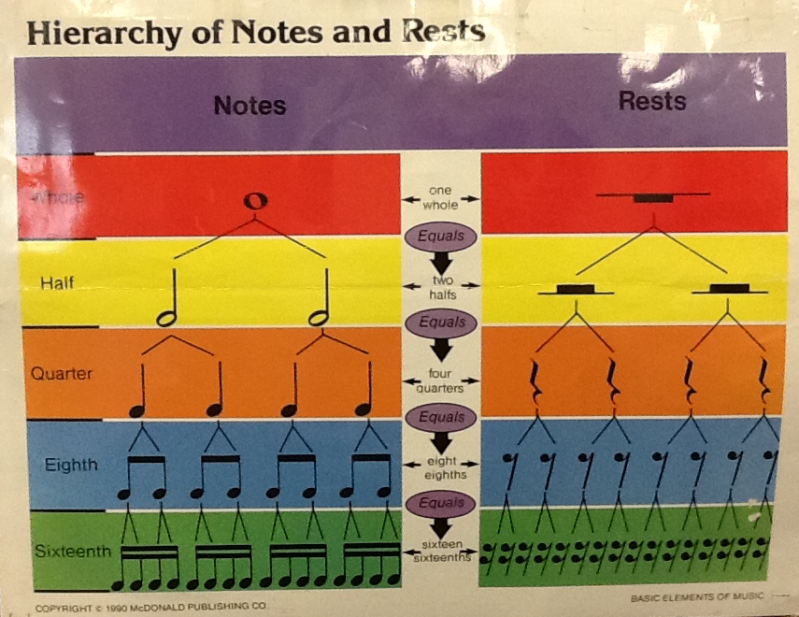
Kodaly Hand Sign Ladder VIP
This VIP for the Kodaly Hand Signs is a little bit more in depth than the one that I would hang in the intermediate/middle school classroom. It adds in the step number and includes when there are half steps. This is information covered in High School.
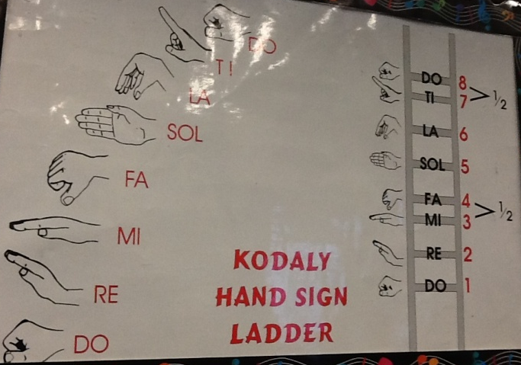

Circle of Fifths VIP
This is a high school appropriate version of the circle of fifths. It goes more into depth and is a good VIP for students to look at when determining keys and many other factors of musical selections.
