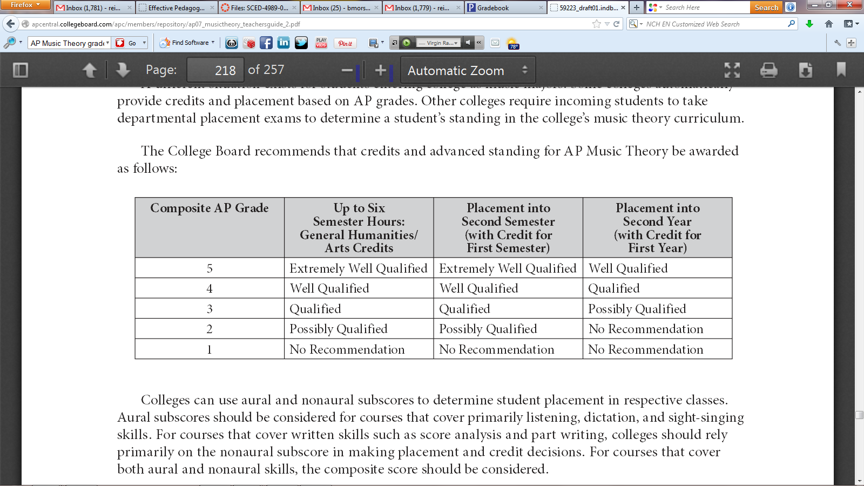

Conversion Chart:
Composite Score Range | AP Grade
132-200 | 5
105-131 | 4
78-104 | 3
47-77 | 2
0-46 | 1

