CLASSROOM ARRANGEMENTS FOR A CHORAL CLASSROOM
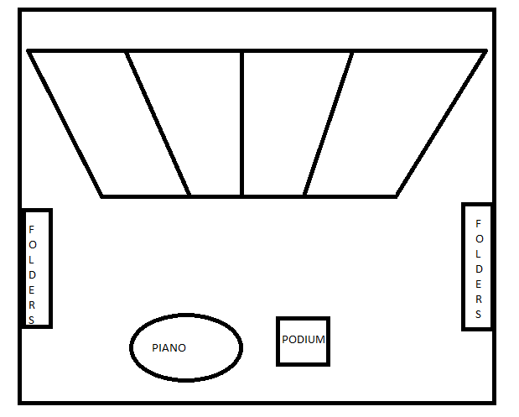
GENERIC SET UP:
The seating will be better explained in the next diagram. This picture is provided to discuss the pertinent areas of the music classroom. The podium is where the teacher stands and conducts from. It must be positioned in a location that is in front of everyone. Every student must be able to easily see the teacher when dealing with podium placement. The piano needs to be set up where the pianist can easily see the teacher/conductor. The front of the room is the generic place and typically works out best. The place it is seen in the picture above is where it will also be placed for a concert. The four interlocking blocks in the middle of the classroom are the chairs. The chairs will be numbered. The boxes labeled "folders" on the sides of the classroom are shelves that will have number slots in them which correspond to the numbers on the chairs. The students will keep their music folder and journal in their assigned number slot. Items such as the teacher's desk are not included in this diagram because typically fine arts classroom have an attached office. Next to this office will be a table where students can turn in work. Graded work will be returned to students individually numbered slots.
The following arrangements do not include all of the details of the classroom, they simply focus on choral arrangement.

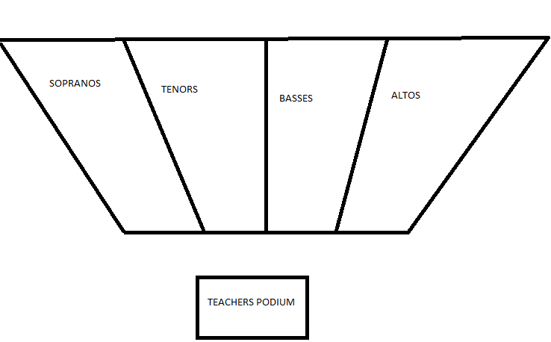

REGULAR SEATING ARRANGEMENT:
Seating the choir in such an arrangement has many benefits. The order of seating soprano, tenors, basses, altos is a very generic choral set up. Not only does it help the teacher hear all four parts evenly, but it also helps students hear their own parts as well as those around them. Oftentimes in music, basses and altos will have a similar part as will sopranos and tenors. Therefore, sitting them near one another can speed the curve of learning up a drastic amount.

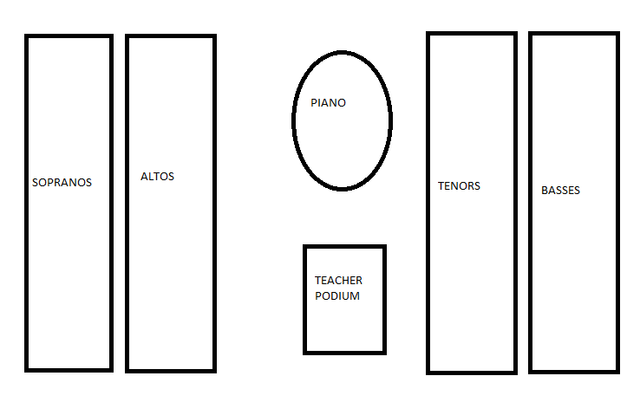
SPLIT CHORAL ARRANGEMENT:
I call this set up split choral arrangement not only because of the physical appearance of the diagram, but also because the girls are on one side and the boys on the other. Depending on the age of students, sometimes this approach is most effective simply because it reduces the talking. Switching to this arrangement occasionally from the generic set up also allows different sections to sit by each other. This will allow students to associate their parts to a part that is usually not next to them. This arrangement also increases sectional strength.

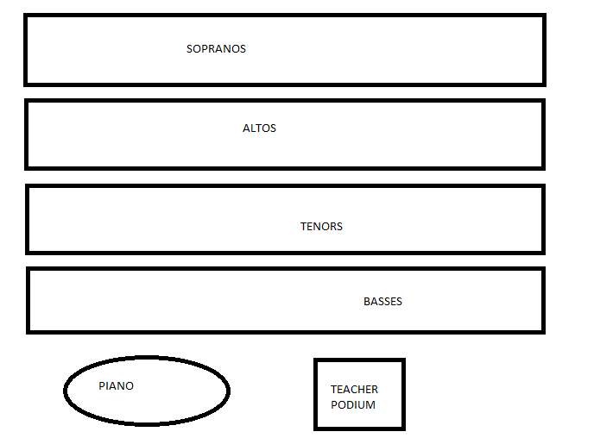

LAYERED ARRANGEMENT:
On occasion, I will find a choir whose men seem to be struggling with their parts more than the women. When this is the case, I switch the choir to layered arrangement because it gets the men closer up front. They are generally more focused when on the front couple of rows. Any of these arrangements have alternate set ups by switching the location of the sections. For example, if the sopranos where struggling the most on a piece, I would put them on the front row in this layered arrangement.

